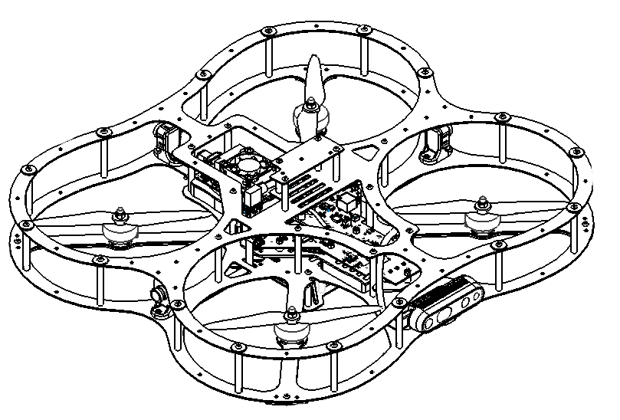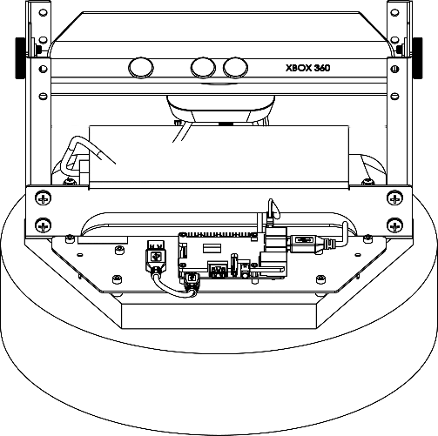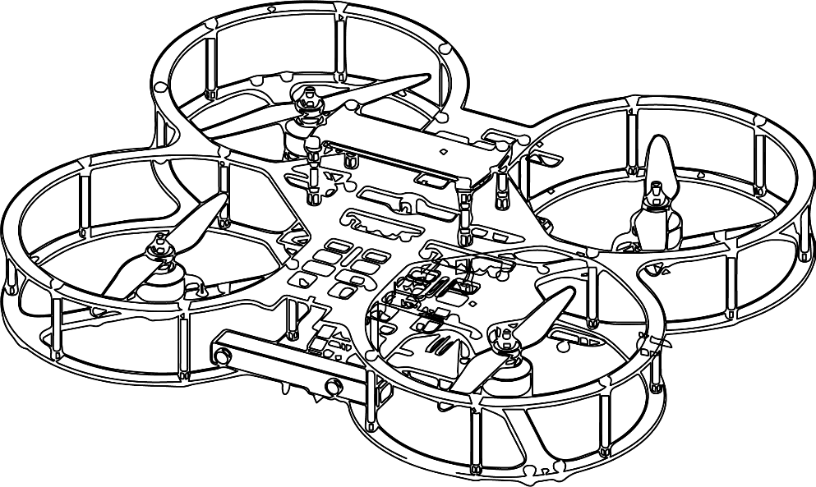

**Autonomous Vehicles Research Studio**

Setup Guide – Defining Rigid Bodies in Motive

$v 2.0 - 18th April 2023$

© 2023 Quanser Inc., All rights reserved

For more information on the solutions Quanser Inc. offers,   
please visit the web site at: <http://www.quanser.com>

|  |  |
| --- | --- |
| Quanser Inc.  119 Spy Court  Markham, Ontario  L3R 5H6, Canada | info@quanser.com  Phone : 19059403575  Fax : 19059403576  printed in Markham, Ontario. |

This document and the software described in it are provided subject to a license agreement. Neither the software nor this document may be used or copied except as specified under the terms of that license agreement. Quanser Inc. grants the following rights: a) The right to reproduce the work, to incorporate the work into one or more collections, and to reproduce the work as incorporated in the collections, b) to create and reproduce adaptations provided reasonable steps are taken to clearly identify the changes that were made to the original work, c) to distribute and publicly perform the work including as incorporated in collections, and d) to distribute and publicly perform adaptations. The above rights may be exercised in all media and formats whether now known or hereafter devised. These rights are granted subject to and limited by the following restrictions: a) You may not exercise any of the rights granted to You in above in any manner that is primarily intended for or directed toward commercial advantage or private monetary compensation, and b) You must keep intact all copyright notices for the Work and provide the name Quanser Inc. for attribution. These restrictions may not be waved without express prior written permission of Quanser Inc.

**FCC Notice** This device complies with Part 15 of the FCC rules. Operation is subject to the following two conditions: (1) this device may not cause harmful interference, and (2) this device must accept any interference received, including interference that may cause undesired operation.

**Industry Canada Notice** This Class A digital apparatus complies with Canadian ICES-003. Cet appareil numérique de la classe A est conforme à la norme NMB-003 du Canada.

**Waste Electrical and Electronic Equipment (WEEE)**

This symbol indicates that waste products must be disposed of separately from municipal household waste, according to Directive 2002/96/EC of the European Parliament and the Council on waste electrical and electronic equipment (WEEE). All products at the end of their life cycle must be sent to a WEEE collection and recycling center. Proper WEEE disposal reduces the environmental impact and the risk to human health due to potentially hazardous substances used in such equipment. Your cooperation in proper WEEE disposal will contribute to the effective usage of natural resources.

|  |  |
| --- | --- |
|  | This product meets the essential requirements of applicable European Directives as follows:   * 2006/95/EC; Low-Voltage Directive (safety) * 2004/108/EC; Electromagnetic Compatibility Directive (EMC)   **Warning**: This is a Class A product. In a domestic environment this product may cause radio interference, in which case the user may be required to take adequate measures. |
| caution.png **Caution** | **This equipment is designed to be used for educational and research purposes and is not intended for use by the public.** The user is responsible to ensure that the equipment will be used by technically qualified personnel only. While the end-effector board provides connections for external user devices, users are responsible for certifying any modifications or additions they make to the default configuration. |

Table of Contents

A. Defining Rigid Bodies in Motive 3

i. Rigid Body Configuration 3

ii. Rigid Body Definition 4

B. Checkpoint – Localization Visualization Demo 11

C. Marker Configurations 13

i. QDrone 1 13

ii. QDrone 2 14

iii. QBot 2 15

# A. Defining Rigid Bodies in Motive

|  |
| --- |
| **Note**: Before defining rigid bodies, place a few markers on the workspace floor and observe their tracking in Motive. Flickering or missing markers may be an indication that a new calibration is required or that the cameras have not reached operating temperature. Calibrating cameras at least once a month is best practice. |

Getting Motive to track your vehicles involves 2 steps:

1. **Rigid Body Configuration:** placing markers on the vehicles so that the cameras can see  
   This involves identifying unique marker configurations that are rigidly attached to each vehicle, and hence, translate/rotate with the vehicle.
2. **Rigid Body Definition:** tagging the rigid body configuration above in Motive:  
   This involves configuring Motive to recognize what the rigid body looks like, so it can track its translation/rotation using the marker configuration.

## i. Rigid Body Configuration

In Section C. Marker Configurations, we provide 10 unique configurations for the QDrone 1, 10 for QDrone 2 and 4 for QBot 2 (see: i. QDrone 1, ii. QDrone 2, iii. QBot 2). **Use these in case you have more than one of each product to be able to distinguish them in flight if both are in the space.** The marker positioning that the drones have when shipped and that we recommend for QBot are the following:

|  |  |  |
| --- | --- | --- |
|  |  |  |
| QDrone 1 Markers | **Qdrone 2 Markers** | **QBot 2 Markers** |

Table 1. Initial marker positioning for products.

However, if you have more than one product of each, make each marker pattern unique. The ones in section C have already been validated. In case you want to use your own configurations, note the following important considerations.

|  |
| --- |
| **Note**: The marker configurations for each rigid body operating within the workspace simultaneously must be unique in order for the Motive software to be able to clearly identify one rigid body from another. |

|  |
| --- |
| **Note**: It is recommended that five or more markers be used per vehicle, e.g., 5 markers for QDrones and 7 markers for Qbot 2/2e. This adds redundancy leading to higher robustness because Motive will be less prone to losing tracking due to a single marker that isn’t visible. This also reduces the chance that the solution to the pose estimates may be interchanged/confused amongst vehicles. |

|  |
| --- |
| **Note**: The placement of the markers on the rigid body must be in a pattern that is NOT symmetric about any arbitrary plane, as it may result in aliasing. For example, placing four markers in a square configuration would lead to ambiguous orientation solutions in 90° intervals. This would make it impossible to discern 90° rotations. |

|  |
| --- |
| **Note**: Make use of different heights when placing markers; for example, placing a marker on the QDrone’s handle as well as top frame, or placing markers near the base of the QBot 2 as well as above its camera. |

|  |
| --- |
| **Note**: The QDrone uses markers with threaded holes, held in place using screws. For the QBot 2, use a hot glue gun to secure markers in place. |

|  |
| --- |
| **Note**: Please contact [tech@quanser.com](mailto:tech@quanser.com) if additional markers are needed. |

## ii. Rigid Body Definition

Once the rigid bodies are configured (markers being positioned) according to the guidelines in the previous section, they must be assigned an ID in Motive. This can be done for single vehicles, or multiple vehicles at the same time. This section covers details on both. Note that the instructions here are for Motive 2.0.1, but later versions may have very similar steps.

|  |
| --- |
| **Important**: Ensure that the cameras have been calibrated and warmed up for at least 15 minutes prior to defining rigid bodies. |

|  |
| --- |
| **Note**: If the markers on the vehicles get damaged or fall off, they should be replaced. Redefining the rigid body in Motive is highly recommended to retain accuracy in the vehicle’s pose measurement. |

|  |
| --- |
| **Note:** When a vehicle’s rigid body is defined in Motive, it identifies the vehicle’s yaw reading as 0 the way it is placed. Ensure that you place the QDrone  1/2/QBot 2 in the workspace oriented as shown in Figure 1 when defining the rigid bodies. This means **always ensuring the vehicle’s camera is pointed away from the ground control station PC.** This will provide consistency in measurement throughout the demo models and controllers provided with the **Autonomous Vehicles Research Studio**. |

x

x

z

y

Research Studio Frame

Motive

Frame

GROUND STATION PC

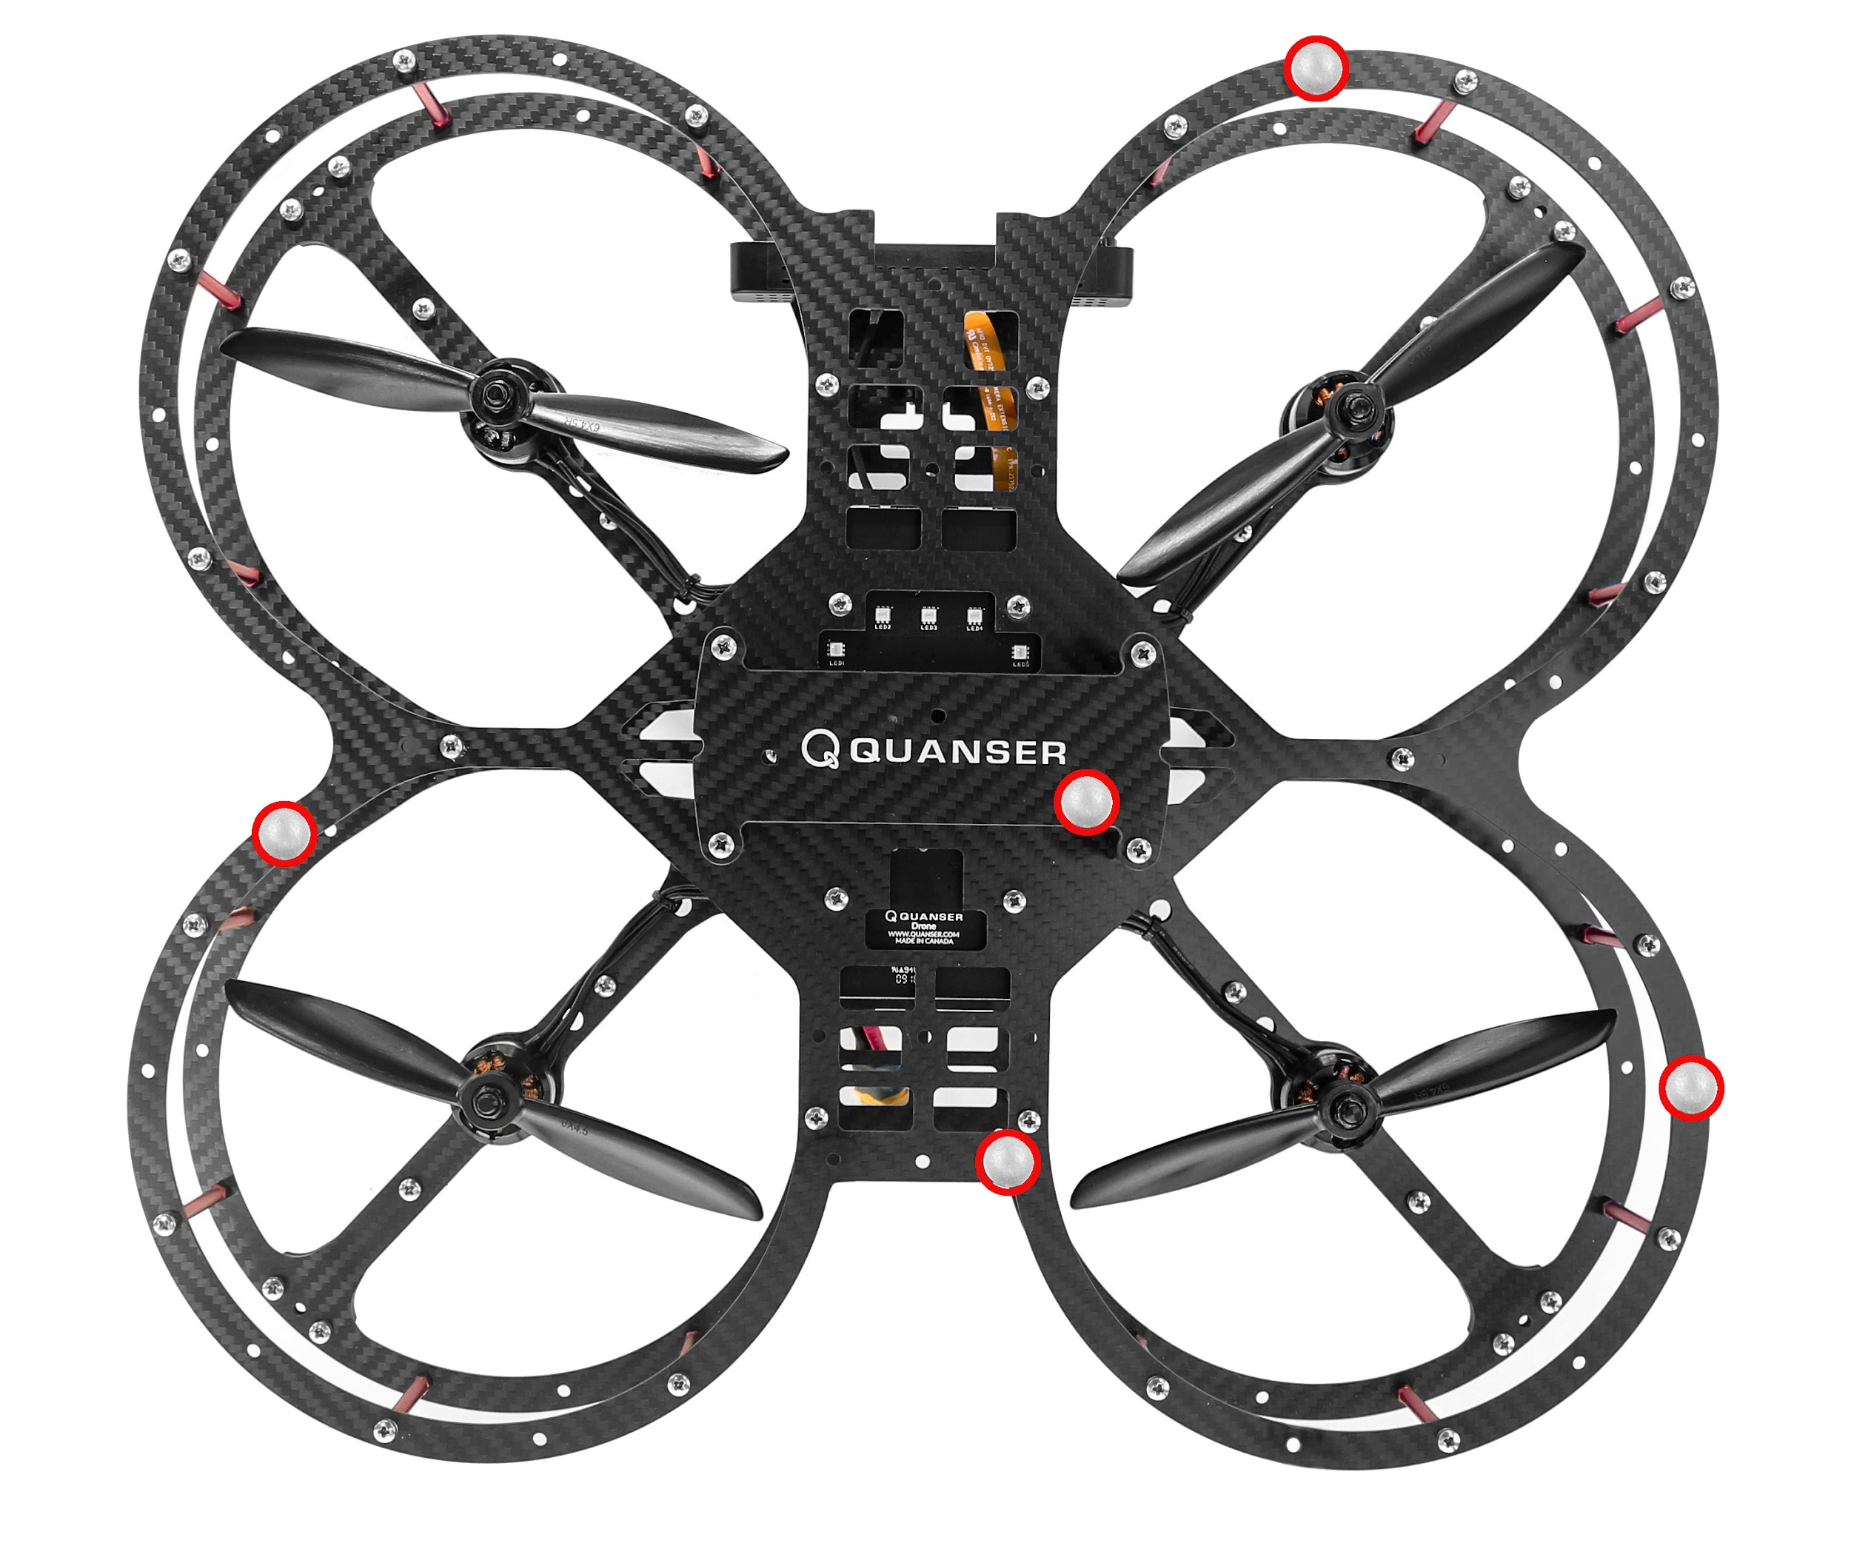

Cameras face away from ground station

battery plug faces ground station

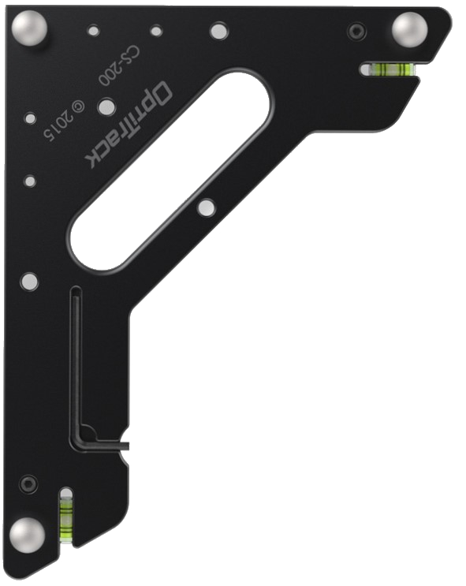

z

x

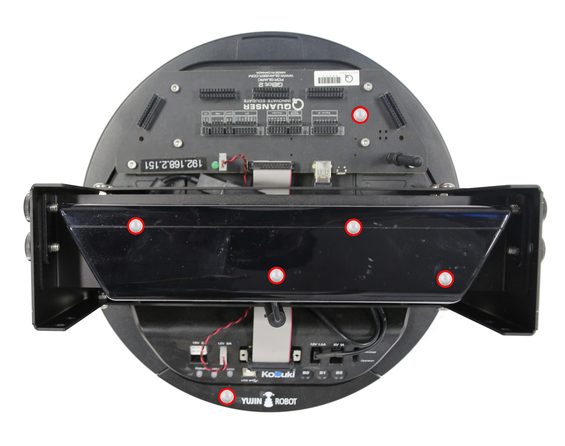

Kinect camera face away from ground station

LEDs face ground station

x

y

x

y

QDrone Body

Frame

QBot 2/2e Body Frame

Figure 1. Vehicle placement orientation in workspace when defining rigid bodies in Motive

|  |  |  |
| --- | --- | --- |
| * + - 1. Open Motive. In the Quick Start menu (Figure 2), select the calibration file (*.cal) that was created when calibrating the cameras. If the Quick Start menu does not open, the calibration file can be loaded from the File menu as well. After the file loads, also load the Profile (File > Load Profile) saved when calibrating cameras. This will ensure no rigid bodies are currently in the workspace. | |  |
| Figure 2: Quick Start menu in Motive 2.0.1 | |
| * + - 1. Place the vehicle in the workspace according to the frame guidelines in Figure 1 (Camera of the vehicle towards the back of the room away from the ground station PC). Motive should display the markers picked up by the cameras in the Perspective View, (Figure 3). |  | |
| Figure 3: Perspective view  in Motive 2.0.1 |
|  |  | |

1. Drag and select all the markers in the Perspective View window, right-click, and select Rigid Body > Create From Selected Markers. (Figure 4)

|  |
| --- |
|  |
| Figure 4.  Creating rigid body from selected markers |

* + - 1. Motive now shows the properties of the rigid body defined (Figure 5). Ensure that the Streaming ID is set to 1 (default). If the Properties pane does not get displayed by default, you may access it from the View > Properties pane.

|  |
| --- |
| Figure 5. Properties pane |

1. If you have a QDrone 2, you might need to move the pivot point to the geometric center of the drone for better tracking, steps 6 to 9 will explain this. If you have a QBot 2/2e or a QDrone 1 this might not be necessary, you can skip to step 10 that explains how to save this rigid body.
2. Open the builder pane (Figure 6a). Click **View>Builder Pane**. Drag and select the rigid body, and inside the Builder pane, click on Edit (Figure 6b).

|  |  |
| --- | --- |
|  |  |
| a. Opening the  Builder Pane | b. Selecting the edit option in the Builder Pane while the drone’s rigid body is selected |
| Figure 6. Builder Pane in Motive | |

1. While the rigid body is selected, in the properties pane, scroll down to see all the markers position. If you only have one marker on the handle, find that marker in the list since that one is positioned in the actual center of the drone, it should be the one with the largest and most positive Y position as shown in figure 7.

|  |
| --- |
|  |
| Figure 7. Finding the top center marker |

1. Since we know that the top center marker is at the actual center of the drone (only higher), we want to use that as reference. So, we first want to move the pivot point to it. In the Builder Pane, under the Edit tab, write down the position of the top marker you found in the previous step as the location values and click apply (Figure 8a). In the main workspace screen, you should see the pivot point move towards the position of the top marker as shown in figure 8b and 8c.

|  |  |
| --- | --- |
| a. Setting the location of the top marker | b. Pivot point before applying the change    c. Pivot point at the position of the top marker (notice how the red and blue line are now coming from the top marker instead of the geometric center between the markers) |
| Figure 8. Moving the pivot point to the position of the top center handle marker | |

1. After the pivot point moved, change the location values in X and Z to zero (o) and the Y value to -70 mm (shown in figure 9a) and click Apply. This is done as the real center of the Drone is at the PCB level which is 7 cm under the top center marker as shown in figure 9b.

|  |  |
| --- | --- |
| a. Moving the pivot point | b. Lowering the pivot point directly under the top marker |
| Figure 9. Lowering the pivot point | |

1. Drag and select the rigid body just defined and click on File > Export Rigid Bodies … (As shown on figure 10). Save the *.tra or *.motive file with a convenient name in the same folder as the camera calibration (*.cal).

|  |
| --- |
|  |
| Figure 10.   Exporting rigid body to a trackable file |

**USE THE FOLLOWING INSTRUCTIONS IF YOU ARE GOING TO BE RUNNING MULTI VEHICLE SCENARIOS**

1. For multi-vehicle scenarios, all the vehicles must be defined in a single trackable file (*.tra). After step 4, place the second vehicle in the workspace and define a new rigid body (similar to step 3) (Figure 11).

|  |
| --- |
|  |
| Figure 11.   Exporting rigid body to a trackable file |

1. The properties pane should now display the second rigid body’s properties. Ensure that the streaming ID is set to 2 (default) as shown in Figure 12.

|  |
| --- |
|  |
| Figure 12.   Exporting rigid body to a trackable file |

1. Repeat steps 11 and 12 for all vehicles involved. Drag and select **ALL** the vehicles, and click on File > Export Rigid Bodies… (similar to step 10). Save the rigid body trackable (*.tra or *.motive) file in the same location as the camera calibration (*.cal) file.

|  |
| --- |
| **Note:** **Make a note of the order in which these vehicles were defined, and the Streaming IDs of these vehicles as well.** Later, the vehicle data will be retrieved in MATLAB/Simulink in the same order. |

# B. Checkpoint – Localization Visualization Demo

1. From the same folder as this file, open Localization Visualization Demo Folder and open LocalizationVisualization_2019a.slx

|  |  |  |
| --- | --- | --- |
|  |  |  |
| a. Localization subsystems | b. Optitrack Trackables block | c. Calibration and Trackable file selection |
| Figure 13: Specifying Calibration (*.cal) and Trackable (*.tra) definition files | | |

1. If you are using Vicon instead of Optitrack, follow the instructions in the model to change the system you are using and set things up correctly.
2. Open the **Localization (Optitrack)** subsystem (Figure 13a), and double-click on the **Optitrack Trackables** block (Figure 13b). Select the calibration file (*.cal) defined in **Calibrating Optitrack Cameras** (step 11) and the rigid body trackables definition file (*.tra or *.motive) defined in the **Rigid Body Definition** section (Figure 13c) for the QDrone.
3. Place the QDrone 1/2 in the workspace at the origin of the Research Studio Frame in the same orientation as when defining the rigid body in the section above (camera looking away from the studio PC). Make sure the QDrone used here matches the tracking ID specified in the previous step.  
   **NOTE:** You DO NOT need to power the QDrones.   
   **NOTE:** No Battery is required for this demo.
4. Back at the root level in the model, click on the **HARDWARE** tab on the top menu and click the green play button (**Monitor & Tune**), This should build and Start the model. (If you are using an older version of MATLAB and do not have a hardware tab, under the **QUARC drop menu**, click **Build**. Once it is complete, click on **Start** under the same menu.)
5. Ensure that the **isTracking?** display reads 1 (the drone is being tracked by the Localization System).
6. Step into the workspace and move the drone around manually.
7. The RED frame will move with the QDrone, giving you a sense of the QDrone’s orientation.
8. Stop the model by clicking the Stop button under the Hardware Tab.

This completes the checkpoint task and confirms that your Localization System has been configured successfully with the rigid bodies in the space. If you have any errors, make sure that all the steps prior to this checkpoint have been followed. If further issues persist, please contact Quanser technical support (tech@quanser.com).

# C. Marker Configurations

## i. QDrone 1

|  |  |  |
| --- | --- | --- |
|  |  |  |
| 1 | 2 | 3 |
|  |  |  |
| 4 | 5 | 6 |
|  |  |  |
| 7 | 8 | 9 |
|  | 10 Unique Qdrone 1 Marker Configurations | |
| 10 |

## ii. QDrone 2

|  |  |  |
| --- | --- | --- |
|  |  |  |
| 1 | 2 | 3 |
|  |  |  |
| 4 | 5 | 6 |
|  |  |  |
| 7 | 8 | 9 |
|  | 10 Unique QDrone 2 Marker Configurations | |
| 10 |

## iii. QBot 2

|  |  |
| --- | --- |
|  |  |
| 1 | 2 |
|  |  |
| 3 | 4 |
| 4 Unique QBot 2 Marker Configurations | |

© Quanser Inc., All rights reserved.

Solutions for teaching and research. Made in Canada.